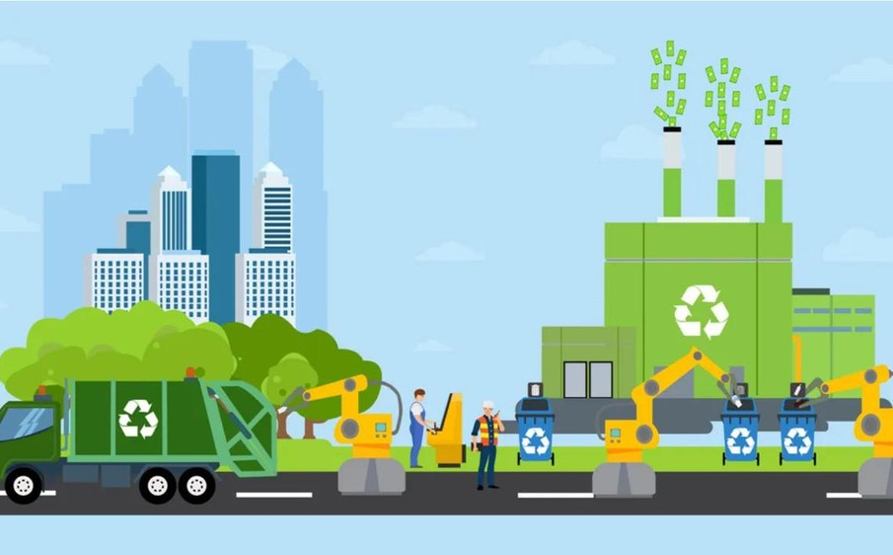

### I B M P O R J E C T S P R I N T D E L I V E R Y P L A N 1

TEAM ID:PNT2022TMID31031

**NOVEMBER 2 0 2 2**

SPRINT 1 REPORT

**I M A G E U S E D F O R E D U C A T I O N P U R P O S E O N L Y S H U T T E R S T O C K - 1 4 3 7 3 4 0 8 5 3 _ 4 F 8 D . 1 2 4 8 . J P G**

# PRE-REQUSTIES



## A L I T T L E A B O U T O U R P R O J E C T

The project was choosen and started on sep 2022 based on IBM and ANNA

University Collab with an intiative to

motivate students by the government, Our choosen project was Smart city waste

mangament for metroploitician cities

**0 1**

# Registred Members

**THARANI- T E A M L E A D E R**

**SOWMIYA- T E A M M E M B E R**

**PAVITHRA-T E A M M E M B E R**

**PRIYADHARSHINI - T E A M M E M B E R**

**0 2**

environment setup

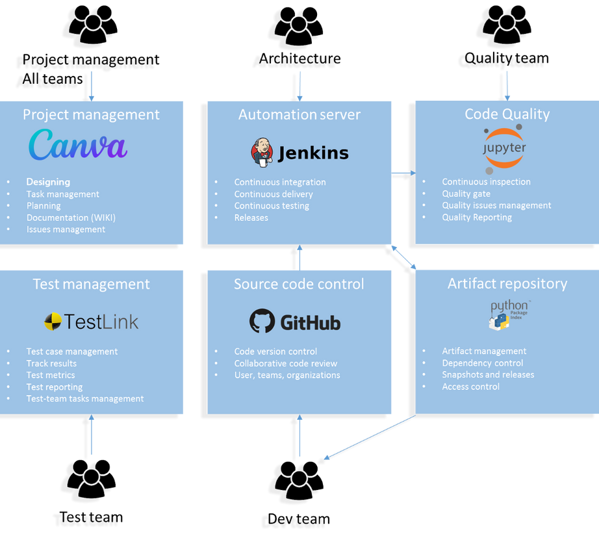

**0 3**